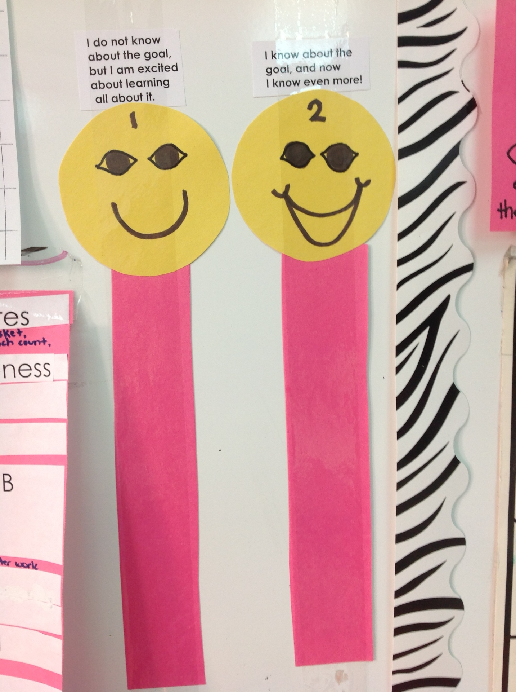**Kindergarten Objective Scoring Rubric**

Susan Craton