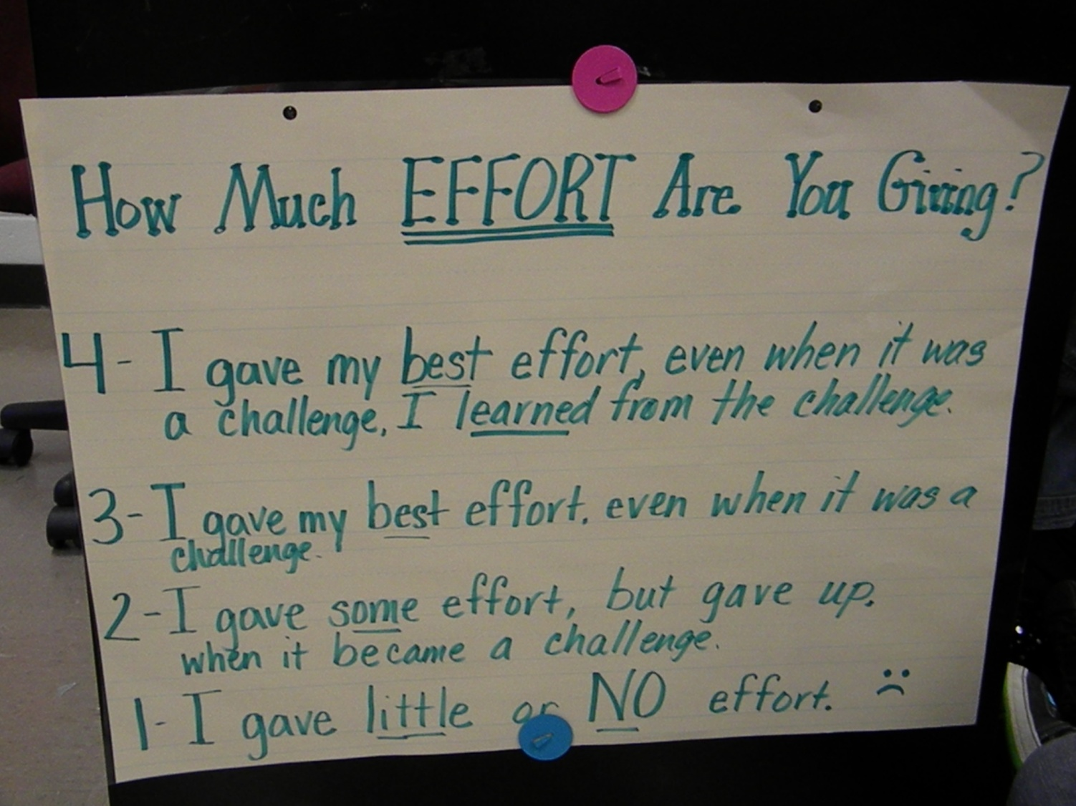5th Grade Effort Rubric

Mrs. Harp

Lowell Elementary