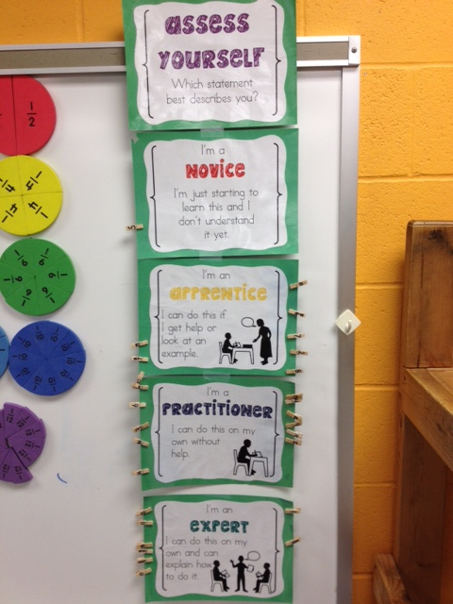

4th Grade

**Objective Scoring Rubric**

* V. Bayles