Third Grade Scoring Rubric

Ms. Sallis

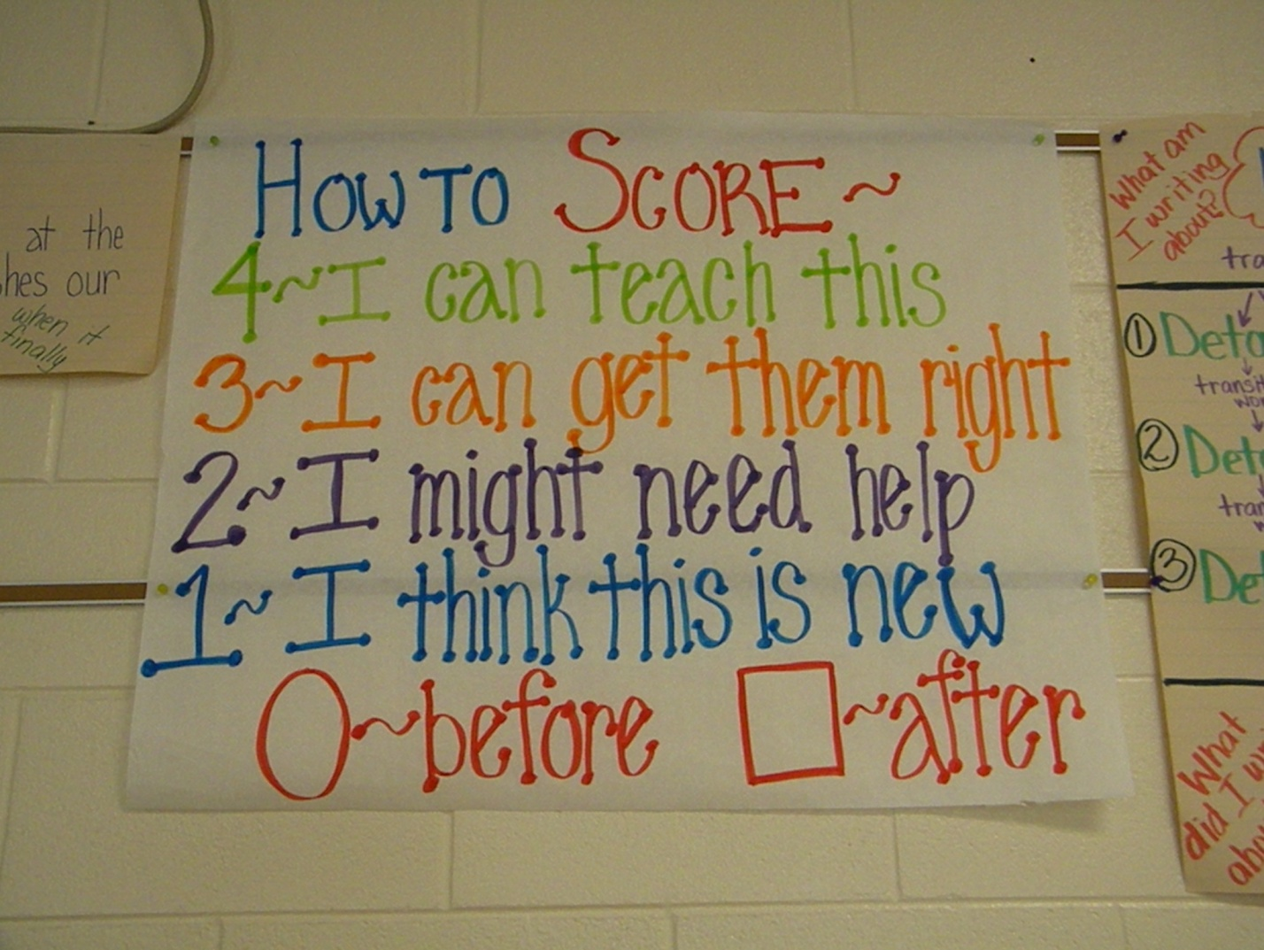Grace Hill Elementary