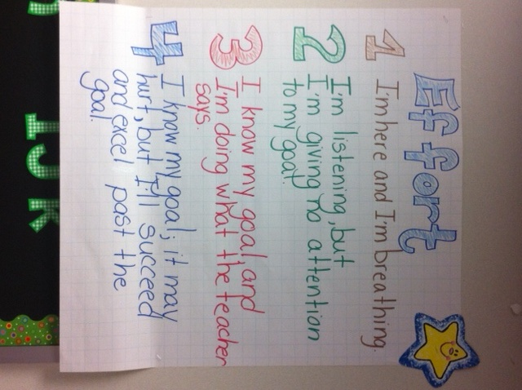**Second Grade Effort Rubric**

Mrs. Clowers

Bellview Elementary