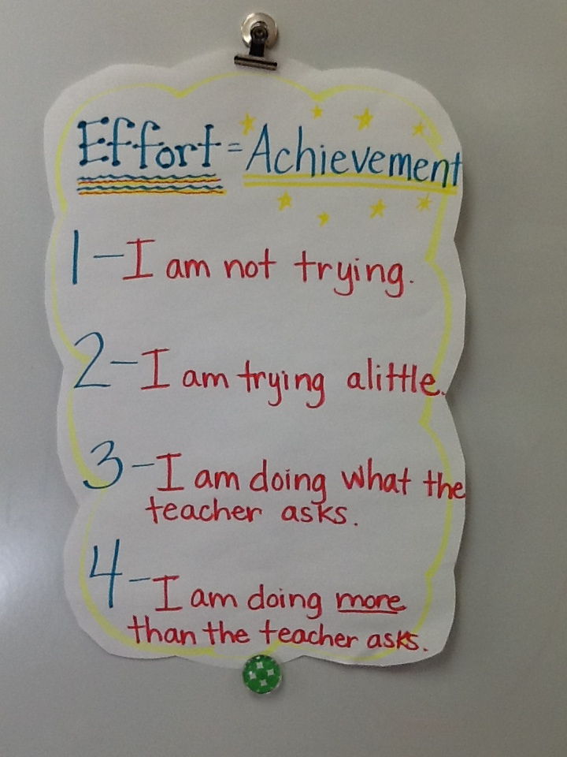First Grade Effort Rubric

* Karen Stitt