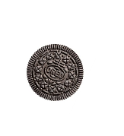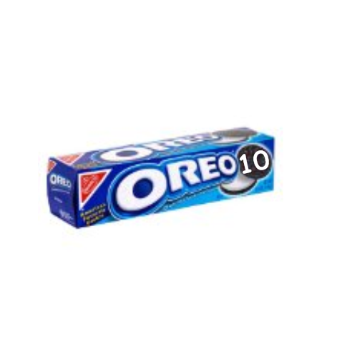

After the Holiday Party, there was **1** unopened box of **10** Oreos and **8** leftover Oreos on a plate. How many cookies were left all together?