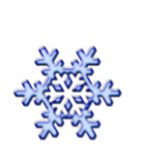There are **16** snowflakes falling from the sky. **6** melt. How many snowflakes are left?