Name: ____________________

1. Suppose you build a tower of interlocking cubes that are:

* 2 cubes high
* 5 cubes high
* 6 cubes high
* 10 cubes high

If you have to paint the outside faces of each square of the tower, how many squares would you have to paint for each tower? Explain a rule for finding the number of painted squares for the towers.

1. Use the previous tower problem as the basis for this task:

* Create coordinates of the number of cubes to make the tower and the number of the painted squares.
* Graph these coordinates and explain the appearance of the graph.
* How would the graph change if the tower were 2 cubes wide?

|  |  |
| --- | --- |
| Cubes High | Painted Faces |
| 2 |  |
| 5 |  |
| 6 |  |
| 10 |  |

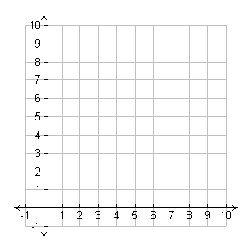**Standard addressed by these tasks:**

5.OA.3 Generate two numerical patterns using two given rules. Identify apparent relationships between corresponding terms. Form ordered pairs consisting of corresponding terms from the two patterns, and graph the ordered pairs on a coordinate plane. For example, given the rule “Add 3” and the starting number 0, and given the rule “Add 6” and the starting number 0, generate terms in the resulting sequences, and observe that the terms in one sequence are twice the corresponding terms in the other sequence. Explain informally why this is so.

**Teacher Notes:**

* In part 1, students must visualize the tower and faces that are not visible, and find a formula to describe this pattern of growth (+4 rule). There are four faces added with each cube, so the graph will create a straight line.
* In part 2, students must demonstrate all they did for the previous task and analyze the change that would occur with a new condition. The function will still make a line, but instead of a +4 pattern, the growth will be +6, so the line will be a little steeper.

*\*These tasks have been adapted from tasks shared at the CCSSM NOLA 2012 conference.*