Name: ____________________

Row 1

Row 2

1. The picture above shows a triangular figure being built. Complete the table to show how many blocks are added as each new row is built. Then describe the pattern that emerges.

|  |  |
| --- | --- |
| Rows | Triangles |
| 1 | 1 |
| 2 | 3 |
| 3 | ? |
| 5 | ? |
| 7 | ? |
| 10 | ? |

1. Using the table created for the first part, create a graph for the situation. Connect all the points on the graph and describe the line. Explain what the line tells you about the situation.

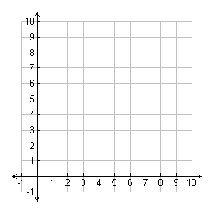

**Standard addressed by these tasks:**

5.OA.3 Generate two numerical patterns using two given rules. Identify apparent relationships between corresponding terms. Form ordered pairs consisting of corresponding terms from the two patterns, and graph the ordered pairs on a coordinate plane. For example, given the rule “Add 3” and the starting number 0, and given the rule “Add 6” and the starting number 0, generate terms in the resulting sequences, and observe that the terms in one sequence are twice the corresponding terms in the other sequence. Explain informally why this is so.

**Teacher Notes:**

* Students may use manipulatives, such as pattern blocks, to help them reason about this problem.
* This multi-step task engages students in describing a recursive pattern in which each successive row builds on the last. Students must describe the pattern they see.
* In part 2 of the task, students must visualize the data in a graph which they create. The growth of the triangle will created a curved line that becomes steeper as more rows are added. This tells you that you are not adding the same number of blocks in each row.

*\*These tasks have been adapted from tasks shared at the CCSSM NOLA 2012 conference.*