[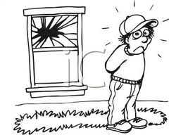](http://www.google.com/url?sa=i&rct=j&q=broken+window+clipart&source=images&cd=&cad=rja&docid=ZBSF97KlFu5EqM&tbnid=1SoC5klk_RhisM:&ved=0CAUQjRw&url=http://www.picturesof.net/pages/100721-167916-816053.html&ei=J-AwUdOLKoa7qgH44ICgDw&psig=AFQjCNFITAmvdaiCWAy9fDmN1AoZrDkCUA&ust=1362243998849465)

Christian was playing ball with his friends and accidently threw the ball through a window. Now he has to replace the glass. The window was ___ inches tall and ____ inches wide. How many square inches of glass will he need to buy to replace the glass?

(30, 20) (30, 20 ½ ) ( 30 ½ , 20 ½ )