Name: ____________________

[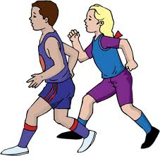](http://www.google.com/imgres?q=running+clipart&hl=en&tbo=d&rls=com.microsoft:en-us&biw=1024&bih=616&tbm=isch&tbnid=kYvBz7mNjx9n1M:&imgrefurl=http://bestclipartblog.com/22-running-clip-art.html/running-clip-art-17&docid=8nCS0WZsC-AMLM&imgurl=http://bestclipartblog.com/clipart-pics/running-clip-art-17.gif&w=367&h=360&ei=5Aa5UJe8MtHvqAHPq4GICA&zoom=1&iact=hc&vpx=135&vpy=259&dur=2359&hovh=222&hovw=227&tx=147&ty=119&sig=110893703310809092446&page=2&tbnh=135&tbnw=138&start=22&ndsp=28&ved=1t:429,r:1,s:22,i:228)Carrie’s coach said that she needs to drink more water to stay hydrated. He challenged her to drink at least 120 ounces of water each day. On Monday, she drank ___ bottles of water. Each bottle contained ____ ounces. Did she meet her coaches’ challenge of drinking at least 120 ounces?

(5, 16.9) (7, 16.9) (8, 16.9) (7.5, 16.9)

Justify your solution with numbers, pictures, and/or words.