Name: ____________________

[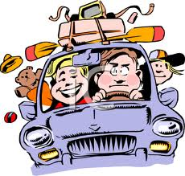](http://www.google.com/imgres?q=family+road+trip+clipart&hl=en&tbo=d&rls=com.microsoft:en-us&biw=1024&bih=616&tbm=isch&tbnid=GfHCK_la0lzx3M:&imgrefurl=http://www.clipartguide.com/_pages/0511-0809-2920-0454.html&docid=lmP67mG91NbY5M&imgurl=http://www.clipartguide.com/_named_clipart_images/0511-0809-2920-0454_Family_Going_on_a_Trip_in_the_Car_clipart_image.jpg&w=350&h=334&ei=bQ25UK0X04erAe3mgaAH&zoom=1&iact=hc&vpx=96&vpy=111&dur=1250&hovh=219&hovw=230&tx=119&ty=92&sig=110893703310809092446&page=1&tbnh=136&tbnw=143&start=0&ndsp=19&ved=1t:429,r:1,s:0,i:88)Sam’s family took a road trip last weekend. It was _____ miles to their destination. It took them ___ hours to drive there. What was their average miles per hour?

(120, 2) (150, 2.5) (227.5, 3.5) (273, 4.2)

Justify your solution with numbers, pictures, and/or words.