Name: ____________________

[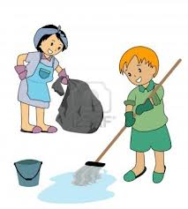](http://www.google.com/imgres?q=kids+cleaning&hl=en&tbo=d&rls=com.microsoft:en-us&biw=1024&bih=616&tbm=isch&tbnid=qidAREb3leU4cM:&imgrefurl=http://www.123rf.com/photo_1830395_illustration-of-kids-cleaning.html&docid=YUaY25dN16q4eM&imgurl=http://us.123rf.com/400wm/400/400/lenm/lenm0710/lenm071000087/1830395-illustration-of-kids-cleaning.jpg&w=1080&h=1200&ei=bBm5UMemK4zpqAGt94DIAw&zoom=1&iact=hc&vpx=611&vpy=62&dur=641&hovh=237&hovw=213&tx=143&ty=134&sig=110893703310809092446&page=1&tbnh=121&tbnw=115&start=0&ndsp=19&ved=1t:429,r:11,s:0,i:185)

Elliott is helping his mom clean house. It took them ____ hour to clean ____ of their house. At that rate, how long will it take them to clean the entire house?

(1, 0.5) (0.5, 0.5) (1.5, 0.5) (2.2, 0.1)

Justify your solution with numbers, pictures, and/or words.