Name __________________­­­­_________________

Name __________________­­­­_________________

Larry, Mo, and Curly entered a pie eating contest as a team. Altogether they scored _____ points. Each friend scored the same number of points for the team. How many points did each friend score?

(21.12) (27.27) (60.33) (96.09)

Justify your solution using numbers, pictures, and/or words.

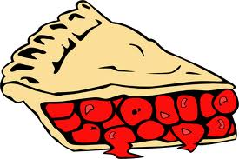

* What standards does this lesson address?
  + **5.NBT.7** Add, subtract, multiply, and divide decimals to hundredths, using concrete models or drawings and strategies based on place value, properties of operations, and/or the relationship between addition and subtraction; relate the strategy to a written method and explain the reasoning used.
    - For this lesson we are focusing on adding and subtracting decimals
  + **5.NBT.3a** Read and write decimals to thousandths using base-ten numerals, number names, and expanded form, e.g., 347.392 = 3 × 100 + 4 × 10 + 7 × 1 + 3 × (1/10) + 9 × (1/100) + 2 × (1/1000).
* Why were these number sets chosen for this problem?
  + The number sets for this problem are all divisible by 3 – the goal is for students to use place value understanding to figure out how many groups of 3 are in numbers such as 21 and 0.12 - they can think of it as 21 shared equally by 3 is 7 and 12 hundredths shared equally by 3 is 4 hundredths
  + Helpful Resources
  + Extending Children’s Mathematics: Fractions and Decimals (Susan B. Empson and Linda Levi)
    - Chapter 7 page 149 -170