Name: ____________________

[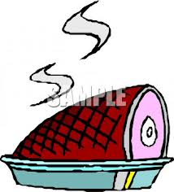](http://www.google.com/imgres?q=christmas+ham+clipart&hl=en&sa=X&tbo=d&rls=com.microsoft:en-us&biw=1024&bih=616&tbm=isch&tbnid=mIVWyltFcHDkeM:&imgrefurl=http://www.clipartguide.com/_pages/0511-1209-2422-1263.html&docid=DF4g-hnrQEZ0CM&imgurl=http://www.clipartguide.com/_named_clipart_images/0511-1209-2422-1263_picture_of_a_ham_sitting_in_a_pan_in_a_vector_clip_art_illustration_clipart_image.jpg&w=318&h=350&ei=WQO5UNamJMTdqgGusYCwDg&zoom=1&iact=hc&vpx=227&vpy=245&dur=516&hovh=236&hovw=214&tx=104&ty=112&sig=110893703310809092446&page=1&tbnh=141&tbnw=126&start=0&ndsp=19&ved=1t:429,r:14,s:0,i:129)

Every year we have a big dinner with our family to celebrate winter birthdays. Our big dinner is coming up and it is time to pick out the ham. When I went to the grocery store to price ham, I saw a sign that said that ham was _____ per pound. I need a big ham to feed everyone, and the biggest ham I found was ____ pounds. How much will the ham cost?

($1.25, 10) ($1.50, 12.5) ($1.60, 15.25)

Justify your solution with numbers, pictures, and/or words.