**Standards addressed by this mini-lesson:**

*Understand the place value system*

* 5.NBT.1 Recognize that in a multi-digit number, a digit in one place represents 10 times as much as it represents in the place to its right and 1/10 of what it represents in the place to its left.
* 5.NBT.2 Explain patterns in the number of zeros of the product when multiplying a number by powers of 10, and explain patterns in the placement of the decimal point when a decimal is multiplied or divided by a power of 10. Use whole-number exponents to denote powers of 10.
* 5.NBT.3 Read, write, and compare decimals to thousandths.
* 5.NBT.3a Read and write decimals to thousandths using base-ten numerals, number names, and expanded form, e.g., 347.392 = 3 × 100 + 4 × 10 + 7 × 1 + 3 × (1/10) + 9 × (1/100) + 2 × (1/1000).

**Materials Needed:**

Math Notebooks or Chart paper

Base 10 blocks

**Lesson:**

1. Put students into groups and give each group some base 10 blocks.
2. Tell students that today they are going to build some numbers using the base 10 blocks and write number sentences that match what they made with the blocks.
3. Give students these numbers: 215 and 2.15
4. Allow students to work together to build each number in at least two different ways. Ask students to record their thinking on a poster or in their math notebooks. Students will have to be creative with the blocks, transferring their thinking about which block represents a whole. If they need some help thinking about it, tell them to consider the hundreds mat as the whole and then have them think what the other blocks might represent.
5. Each group will present one way they built the number to the entire group. The need to present what they did with the blocks and the number sentences that record their thinking.
6. When students present, record each picture and notation on an anchor chart or on the board. Have students record the information in their math notebooks.
7. Ask students what they notice. Pick one or two number sentences and ask them if they are equivalent representations of the number.
   * Ask students how many 10 s are in each number, how many ones, how many tenths, how many hundredths, etc.
   * Ask student to look for similarities between the two numbers and patterns that show up as they notate the numbers in many different ways.

See the following pages for examples of what students might do and the answers to the last questions on the handout (page 3).

**Some examples of what students might do:**

**215 OR 215**

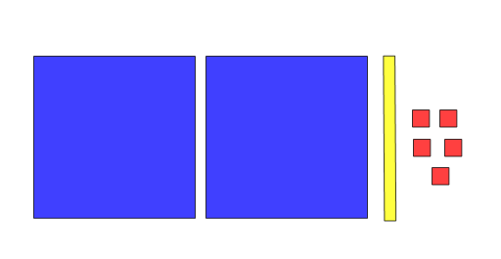 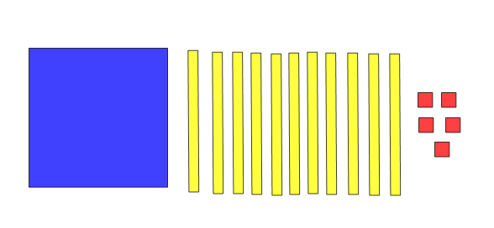

100 + 100 + 10 + 5 or (2 x 100) + (1 x 10) + (5 x 1) 100 + 10+ 10 +10 + 10 +10+ 10 + 10 + 10 + 10 + 10 + 10 + 5

or (1 x 100) + (11 x 10) + (5 x 1)

**2. 15**



1 + 1 + 0.1 + 0.05 **or** (2 x 1) + (1 x 0.1) + (5 x 0.05) **OR**

**2.15**



1 + 0.1 + 0.1 + 0.1 + 0.1 + 0.1 + 0.1 + 0.1 + 0.1 + 0.1 + 0.1 + 0.1 + 0.01 + 0.01 + 0.01 + 0.01 + 0.01

**or** (1 x 1) + (11 x 0.1) + (5 x 0.01)

**Answers to the questions at the bottom:**

* How many tens are in **215**? **21**
* How many ones are in **215**? **215**
* How many ones are in **2.15**? **2**
* How many tenths are in **2.15**? **21**
* How many tenths are in **215**? **2150**
* How many hundredths are in **2.15**? **215**
* How many hundredths are in **215**? **21,500**

Name: _______________

Build **215** with base 10 blocks in at least two ways.

Record what you did with the blocks and write the number sentences that match your work.

Build **2.15** with base 10 blocks in at least two ways.

Record what you did with the blocks and the write number sentences that match your work.

**Answer the following questions and use pictures or number sentences to prove your thinking.**

* How many tens are in **215**?
* How many ones are in **215**?
* How many ones are in **2.15**?
* How many tenths are in **2.15**?
* How many tenths are in **215**?
* How many hundredths are in **2.15**?
* How many hundredths are in **215**?