Name: ____________________

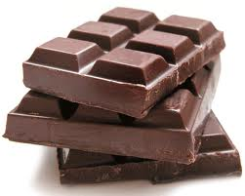

Jan had ___ huge candy bars. She challenged herself to only eat **1/10** candy bar each day. How many days will her chocolate challenge last?

**(3) (6) (10) (12)**

Justify your solution with numbers, pictures, and/or words.