Name: ____________________

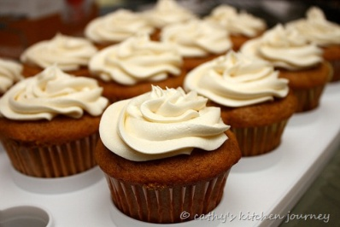

The Cupcake Palace has ___ pounds of frosting. It takes **1/10** of a pound of frosting to frost a cupcake. How many cupcakes could the Cupcake Palace frost before they run out of frosting?

**(10) (15) (25) (47)**

Justify your solution with numbers, pictures, and/or words.