Name: ____________________

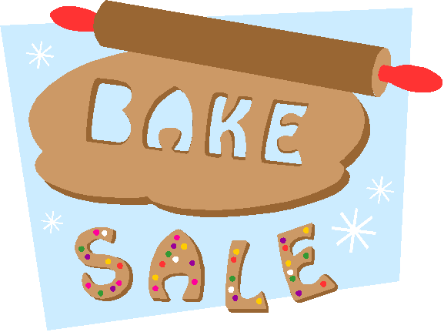

Cathy was making cookies for her school bake sale. She uses **1/10** of a package of cinnamon in each batch of Snickerdoodle cookies she makes. If Cathy has ____ packages of cinnamon, how many batches of Snickerdoodles can she make for the bake sale?

**(1 and one-tenth) (2 and nine-tenths) (3 and seven-tenths)**

Justify your solution with numbers, pictures, and/or words.