Name: ____________________

[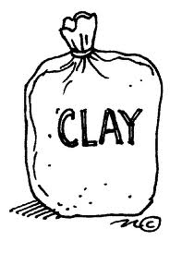](http://www.google.com/imgres?q=clay+pinch+pots&um=1&hl=en&sa=X&rls=com.microsoft:en-us:IE-SearchBox&biw=1024&bih=616&tbs=itp:clipart&tbm=isch&tbnid=wTvgDbYonRULCM:&imgrefurl=http://discoverandlearn.blogspot.com/2008_07_01_archive.html&docid=ukqld72uCvipaM&imgurl=http://school.discoveryeducation.com/clipart/images/claybag.gif&w=500&h=743&ei=IS-tT-OUEMaY6AH459z6DA&zoom=1&iact=hc&vpx=660&vpy=195&dur=1593&hovh=274&hovw=184&tx=108&ty=155&sig=100130348528268509155&page=3&tbnh=134&tbnw=87&start=30&ndsp=22&ved=1t:429,r:15,s:30,i:203)

Mr. Williams has ___ pounds of clay for his fifth grade students to make pinch pots. It takes ____ pounds of clay for each pinch pot. How many pinch pots can the fifth graders make?

**(4, 10) (37, 10) (4, .1) (37, .1) (243, .1)**

Justify your solution with numbers, pictures, and/or words.