Name: ____________________

[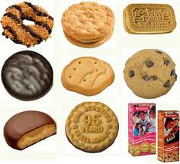](http://www.google.com/imgres?q=girl+scout+cookies&um=1&hl=en&rls=com.microsoft:en-us&biw=1280&bih=648&tbm=isch&tbnid=k1sO8ffXZHoPBM:&imgrefurl=http://blogs.villagevoice.com/forkintheroad/2011/03/samoas_thin_min.php&docid=u-sbPM7BrMfD0M&imgurl=http://blogs.villagevoice.com/forkintheroad/best-selling-girl-scout-cookies.jpg&w=350&h=317&ei=1u28T_rxCKPW2gWA0aiTDw&zoom=1&iact=hc&vpx=351&vpy=167&dur=1688&hovh=214&hovw=236&tx=111&ty=122&sig=115356206564574998490&page=1&tbnh=122&tbnw=137&start=0&ndsp=20&ved=1t:429,r:1,s:0,i:140)

Cassie loves Girl Scout Cookies and her mom always buys a lot to last them throughout the year. Cassie’s mom bought ___ boxes of cookies. Cassie decided that to make them last she will only eat 1/10 of a box each day. How many days will the cookies last?

(10) (34) (55) (100)

Justify your solution with numbers, pictures, and/or words.