[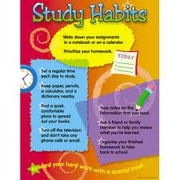](http://www.google.com/url?sa=i&rct=j&q=posters+study+habits&source=images&cd=&cad=rja&docid=tFD5eOj_lwkz3M&tbnid=kFX1WFi1ucCFeM:&ved=0CAUQjRw&url=http://www.bidorbuy.co.za/item/39668697/Poster_Study_habits.html&ei=JNwwUdWrHY2sqQGYiYD4Dw&psig=AFQjCNHmxg9IZ1oM4hTu0L6C3vq3T9pMUw&ust=1362242959951349)

Adrianna wants to cover her walls with posters. Each poster is 11 inches wide and 8 ½ inches tall. If she buys ____ posters, how many square inches of her wall can she cover?

(10) (20) (25) (50)