[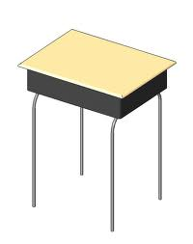](http://www.google.com/url?sa=i&rct=j&q=school+desk&source=images&cd=&cad=rja&docid=MOPR2GyQRvXKXM&tbnid=oLl5DNpHlCCW0M:&ved=0CAUQjRw&url=http://www.revitcity.com/downloads.php?action=view&object_id=6254&ei=lt4wUcyNLtDvqAG7poHIAw&psig=AFQjCNGQLQf8e6EXkgZqbMcH_t7tMQpqWQ&ust=1362243593235895)

The rectangular top of a desk is three times as long as it is wide. Its width is ___ feet. What is the area of desk top?

(2) (1 ½ ) ( 1 ⅔)