Name: ____________________

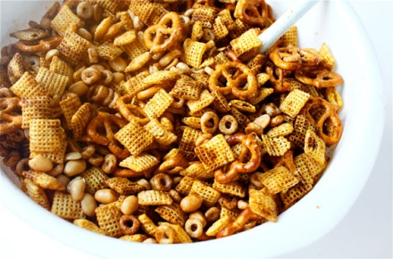Your class made 10 cups of party mix for the fall carnival. You have to put the same amount of party mix in each bag. If you put ___ cups in each bag, how many bags of party mix can you fill?

( 1/3 ) ( ¼ ) ( 1/8 )

Justify your solution with numbers, pictures, and/or words.