Name: ____________________

[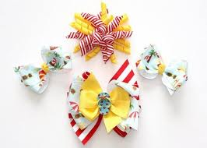](http://www.google.com/imgres?q=bows+for+little+girls&um=1&hl=en&sa=N&rls=com.microsoft:en-us:IE-SearchBox&biw=1024&bih=616&tbm=isch&tbnid=9OvAqyE3JzIzRM:&imgrefurl=http://mommymccart.blogspot.com/2009/05/super-cute-bows.html&docid=nZ65pNPFT025sM&imgurl=http://3.bp.blogspot.com/_60XCNH8rd50/SgTA_qWOSLI/AAAAAAAAAc0/HRur7415qZk/s400/Bows+1&w=400&h=286&ei=O36iT9TJIoe42wWm0bzQCA&zoom=1&iact=hc&vpx=86&vpy=232&dur=703&hovh=190&hovw=266&tx=98&ty=121&sig=108250451886947569919&page=2&tbnh=125&tbnw=161&start=17&ndsp=21&ved=1t:429,r:5,s:17,i:124)

Mrs. Smith is making hair bows for her friend Rea's baby. She has __yards of ribbon. She needs **__** of a yard for each bow. How many bows can Mrs. Smith make?

(3, ½ ) (3, ¾ ) (6, ¾ ) (9, ¾ ) (12, ¾ )

Justify your solution with numbers, pictures, and/or words.