Name: ____________________

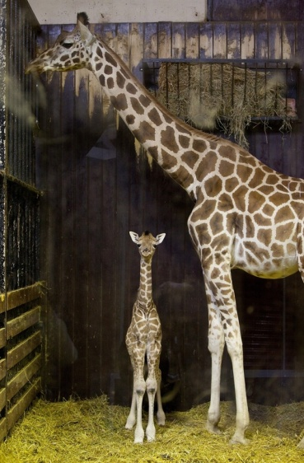An adult giraffe is 18 feet tall. It’s baby is 9 feet tall. The baby is ____ as tall as the mother giraffe.

An adult giraffe is 18 feet tall. It’s baby is 6 feet tall. The baby is ____ as tall as the mother giraffe.

An adult giraffe is 18 feet tall. It’s baby is 12 feet tall. The baby is ____ as tall as the mother giraffe.