[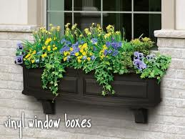](http://www.google.com/url?sa=i&rct=j&q=flower+boxes&source=images&cd=&cad=rja&docid=Xkwka0zzhXOypM&tbnid=I3a7qIYVBvIZOM:&ved=0CAUQjRw&url=http://www.windowbox.com/window-boxes-planters.html&ei=BtcwUd61KMbIqQGUqYBI&bvm=bv.43148975,d.eWU&psig=AFQjCNEUNPOKeG2xp6-rSSIEZwfDaiNq8g&ust=1362241628013909)

1. Kenny bought 8 window boxes to plant some flowers in. Each window box measured 12 inches long, 6 inches wide, and 9 inches tall. How many cubic inches of soil will Kenny need to fill all 8 window box?
2. At the garden store, Kenny finds that all the bags of soil are sold in 1 cubic foot size bags (1 cubic foot = 12 in x 12 in x 12 in). If each bag is 1 cubic foot, how many bags of soil does Kenny need to buy?