[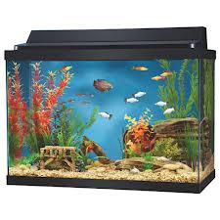](http://www.google.com/url?sa=i&rct=j&q=aquarium&source=images&cd=&cad=rja&docid=vTpU4iD8j7JHlM&tbnid=rbt1-P4ROtIdgM:&ved=0CAUQjRw&url=http://www.northjersey.com/community/house_gardening/181569651_Smart_Shopper__Aquariums.html?mobile=1&ei=C9QwUcjwN9KCrQHAt4DoDg&bvm=bv.43148975,d.eWU&psig=AFQjCNHMpZGGz3tL7VRpg6XkzceFI4MTPw&ust=1362240890449230)

1. Chris’s aquarium is 30 cm tall, 40 cm long, and 30 cm wide. How many cubic cm of water will it hold?
2. Chris really wants guppies to put in his aquarium. Each guppy needs 1800 cubic cm of water to survive. What is the maximum number of guppies he can have in his tank?