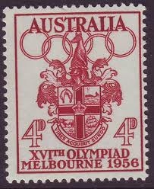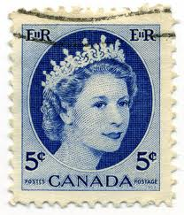

Allison has a large stamp collection. She displayed all her stamps from different countries in a large frame. Allison noticed that there were ___ rows of stamps with

___ stamps in each row. How many stamps are there?

(8, 12) (4, 24) (16, 6)

|  |  |  |  |  |  |  |  |  |  |
| --- | --- | --- | --- | --- | --- | --- | --- | --- | --- |
|  |  |  |  |  |  |  |  |  |  |
|  |  |  |  |  |  |  |  |  |  |
|  |  |  |  |  |  |  |  |  |  |
|  |  |  |  |  |  |  |  |  |  |
|  |  |  |  |  |  |  |  |  |  |
|  |  |  |  |  |  |  |  |  |  |
|  |  |  |  |  |  |  |  |  |  |
|  |  |  |  |  |  |  |  |  |  |
|  |  |  |  |  |  |  |  |  |  |
|  |  |  |  |  |  |  |  |  |  |