[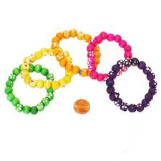](http://www.google.com/imgres?q=bead+bracelets&start=476&num=10&hl=en&tbo=d&biw=965&bih=638&tbm=isch&tbnid=21_T8sNH50ktoM:&imgrefurl=http://www.carnivalsavers.com/catalog/item/7717765/8910989.htm&docid=YP_dMpB5g-GvVM&imgurl=http://www.carnivalsavers.com/i/Under%2025%20Cents/wooden-flower-bead-bracelet.jpg&w=384&h=384&ei=Iw-5UO-yCMLqrQGE4YD4Dw&zoom=1&iact=hc&vpx=172&vpy=79&dur=1247&hovh=225&hovw=225&tx=117&ty=122&sig=110352028126971768232&page=22&tbnh=139&tbnw=139&ndsp=23&ved=1t:429,r:94,s:400,i:286)

Denise helped her aunt make ____ bracelets for a craft sale. They strung ______ beads together to make each bracelet. How many beads did they use to create the bracelets?

(12, 14) (48, 7) (72, 14)

|  |  |  |  |  |  |  |  |  |  |
| --- | --- | --- | --- | --- | --- | --- | --- | --- | --- |
|  |  |  |  |  |  |  |  |  |  |
|  |  |  |  |  |  |  |  |  |  |
|  |  |  |  |  |  |  |  |  |  |
|  |  |  |  |  |  |  |  |  |  |
|  |  |  |  |  |  |  |  |  |  |
|  |  |  |  |  |  |  |  |  |  |
|  |  |  |  |  |  |  |  |  |  |
|  |  |  |  |  |  |  |  |  |  |
|  |  |  |  |  |  |  |  |  |  |
|  |  |  |  |  |  |  |  |  |  |