[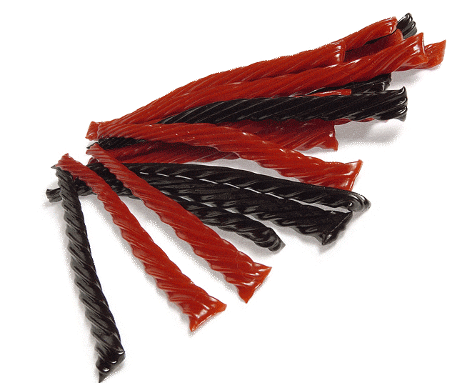](http://www.google.com/url?sa=i&rct=j&q=&esrc=s&source=images&cd=&cad=rja&uact=8&ved=0CAcQjRw&url=http%3A%2F%2Fwww.candyusa.com%2FAllAboutCandy%2FCandyType.cfm%3FItemNumber%3D930&ei=JC1nVbHBFMTisAWw5IGABA&bvm=bv.93990622,d.cGU&psig=AFQjCNFf4Z2fWKJxZxwHLhDjKmkT5WgS8g&ust=1432911519731212)

Sam loves helping in his parents’ candy shop after school.

A customer bought ___ bags of licorice. A bag of licorice weighs ___ pounds. How many pounds of licorice did they buy?

(25, 12) (25, ¼ ) (25, 2 ½ ) (25, 0.6)