[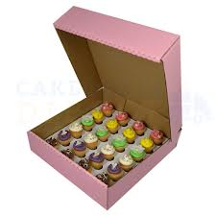](http://www.google.com/url?sa=i&rct=j&q=&esrc=s&source=images&cd=&cad=rja&uact=8&docid=8RH1IoSKBrKHCM&tbnid=c2z4DicqeY_UxM:&ved=0CAcQjRw&url=http://cakeboxesdirect.com/24-mini-pink-corr-cupcake-box-with-dividers.html&ei=KU0TVKtSwbWiBKnhgfgG&bvm=bv.75097201,d.b2U&psig=AFQjCNEXsMI5D9LAUqZCooSazbesTVGGLg&ust=1410637459271582)Mrs. Bookout bought ____ boxes of mini-cupcakes for a birthday party. There were ___ mini-cupcakes in each box. How many cupcakes did she buy?

(15, 12) (15, 36) (10 ½ , 12) (5 ¼, 12)