[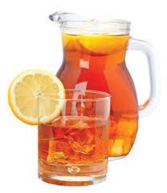](http://www.google.com/imgres?imgurl=http://www.yourlocalhealthchoice.com/wp-content/uploads/sweettea.jpg&imgrefurl=http://www.yourlocalhealthchoice.com/sweet-tea-can-contribute-to-kidney-stones/&h=346&w=300&tbnid=9ERnt3QbUwe17M:&zoom=1&docid=KMxu9RFcAQJXZM&ei=kDhnVfyeLInioATr7oPgDg&tbm=isch&ved=0CD8QMygOMA4)It takes ___ tablespoons of sugar to make 1 gallon of sweet tea. If Mrs. Jesup wants to make ____ gallons of sweet tea, how many tablespoons of sugar does she need?

(12, 15) (12, 45) (12, 10 ¼) (12, 12.5)