[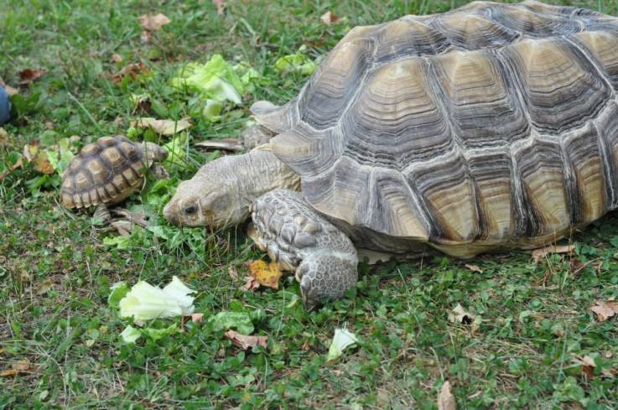](http://www.google.com/url?sa=i&rct=j&q=&esrc=s&source=images&cd=&cad=rja&uact=8&ved=0CAcQjRw&url=http%3A%2F%2Fanimalembassy.com%2Fphoto%2Fsulcata-baby%3Fcontext%3Duser&ei=ui5nVf35AoPosAXYxoPYBA&bvm=bv.93990622,d.cGU&psig=AFQjCNFvktQx_H2FOxTbc6yY8FtHtdKGcQ&ust=1432911919910855)The tortoise at the zoo weighs ___ pounds. It is ___ times heavier than the baby tortoise. How much does the baby tortoise weigh?

(500, 10) (250, 12 ½ ) (69, 1 ⅓) (82.5, 10)