[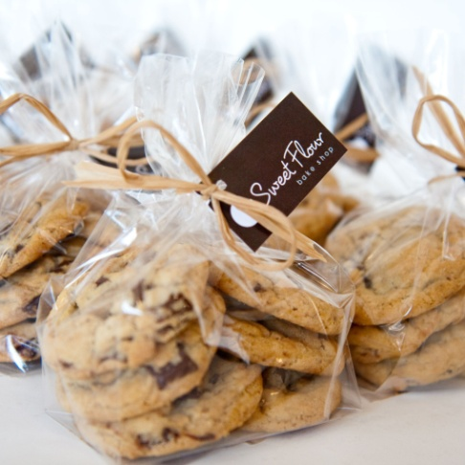](http://www.google.com/url?sa=i&rct=j&q=&esrc=s&source=images&cd=&cad=rja&uact=8&ved=0CAcQjRw&url=http%3A%2F%2Fwww.sweetflour.ca%2Fproducts%2Fgift-bag-of-6-signature-gourmetcookies&ei=aDNnVbniK4mFsAWa0YCoDQ&bvm=bv.93990622,d.cGU&psig=AFQjCNGiyb5RMStuhAsydoNOg_0ATvuLRg&ust=1432913088924751)We have ____ bags of cookies. There are ___ pounds of cookies in each bag. How many pounds of cookies do we have?

(1252, 8) (325, 15) (84, 8 ½ ) (75, 8 ⅓)