Name: ____________________

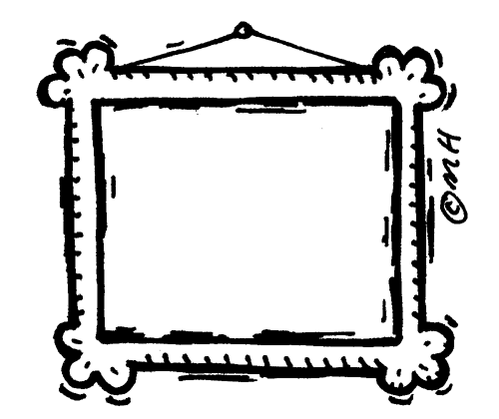

Mrs. Boyd is buying a frame for a picture of her son. She took the picture to Hobby Lobby for them to build the frame. The picture was ___ inches tall and ____ inches wide. How many inches of frame will there be?

(5, 7) (10, 8) (11, 17) (32, 18)

Justify your solution with numbers, pictures, and/or words.