**Standards addressed by this series of mini-lessons:**

*Geometric measurement: understand concepts of area and relate area to multiplication and to addition.*

3.MD.5. Recognize area as an attribute of plane figures and understand concepts of area measurement.

a. A square with side length 1 unit, called “a unit square,” is said to have “one square unit” of area, and can be used to measure area.

b. A plane figure which can be covered without gaps or overlaps by n unit squares is said to have an area of n square units.

3.MD.6. Measure areas by counting unit squares (square cm, square m, square in, square ft, and improvised units).

3.MD.7. Relate area to the operations of multiplication and addition.

1. Find the area of a rectangle with whole-number side lengths by tiling it, and show that the area is the same as would be found by multiplying the side lengths.
2. Multiply side lengths to find areas of rectangles with whole-number side lengths in the context of solving real world and mathematical problems, and represent whole-number products as rectangular areas in mathematical reasoning.
3. Use tiling to show in a concrete case that the area of a rectangle with whole-number side lengths a and b + c is the sum of a × b and a × c. Use area models to represent the distributive property in mathematical reasoning.
4. Recognize area as additive. Find areas of rectilinear figures by decomposing them into non-overlapping rectangles and adding the areas of the non-overlapping parts, applying this technique to solve real world problems.

*Geometric Measurement: recognize perimeter as an attribute of plane figures and distinguish between linear and area measures.*

3.MD.8 Solve real world and mathematical problems involving perimeters of polygons, including finding the perimeter given the side lengths, finding an unknown side length, and exhibiting rectangles with the same perimeter and different areas or with the same area and different perimeters.

**This is a series of mini-lessons that build the concept of area with students. Your students may need all the lessons or may just need a few. Feel free to modify and adjust them to meet the needs of your students.**

**Lesson 1:**

Students need to start with comparison activities when discussing area in order to better understand how to break the larger area into units. Students need to deal with the idea that cutting and rearranging a shape into a new shape retains the same area as the original shape.

Try this activity with students:

* Pair students up and give each pair six 4” x 6” rectangles.
* Have students fold and cut the rectangles on the diagonal, making two identical triangles.
* Have them rearrange the triangles into different shapes, including the original rectangle.
  + The rule is that only sides of the same length can be matched up and must be matched up exactly.
* Have each pair of students find all the shapes that can be made this way, pasting the triangles on paper as a record of each shape.
* Discuss the size and shape of the different results:
  + Is one shape bigger than the other?
  + How is it bigger?
  + Did one take more paper to make, or do they all have the same amount of paper?
* **BIG IDEA:** Although each figure is a different shape, all the figures have the same area.

**Lesson 2:**

* Give students pairs of rectangles that measure as follows (do not label the rectangles- make each a different color so students can discuss the differences):
  + Pair 1: 2 x 8 and a 4 x 4
  + Pair 2: 1 x 10 and a 3 x 5
* Ask students to determine which rectangle in each pair has the greatest area or if the two are the same size. Tell students they can cut or fold the rectangles in any way they wish. Tell students they must justify why they cut or folded the rectangles.
* Have student discuss their findings. What did they notice? How did they compare the two to prove that one was bigger or the same size as the other?
* **BIG IDEA:** Areas can be directly compared.

**Lesson 3:**

* Tape off some (5-7 depending on the size of your groups) big areas in your classroom (i.e a 2’ x 3’ rectangle). Make some rectangular, but make others more trapezoidal (ie. ).
* Put students into small groups and give each group an array of tools to use to find the area of each of the figures you taped off on the floor. Some ideas for materials are: two-color counters, color tiles, post-it notes, pennies, dried lima beans, etc.)
* Assign each group to a figure and give them 5-10 minutes to use their tools to find the area of their figure. You can have each group do only one figure, or have groups rotate through each figure (or at least do two or three to compare with others).
* Observe students as they make choices about what tools they choose and how they are measuring.
* Once students are done measuring their figure(s), bring students together for discussion. Talk about how they measured and what tools were best for finding the area of the figures. Push students to talk about their methods for finding the areas and how they would label their answers.
* If you had the groups do more than one figure, record their findings on the board. Compare the findings of the groups and talk about the reasons why some groups may have gotten a different answer than the others (they used different units, they left gaps or overlaps and weren’t as precise, etc.)
* **BIG IDEA:** Area is measured by covering the surface of a figure.

**Lesson 3:**

* Give students two rectangles either with the same area, or are very close in area. Some suggestions for dimensions are: 4 x10 and 5 x 8, or a 5 x 10 and 7 x 7. Students also need an inch ruler and a square inch.
* Tell students that they have to determine which rectangle has the greatest area without cutting or folding the rectangles. They are allowed to draw on their rectangles and use their unit square and their rulers.
* Have students share their thinking on how they determined which rectangle had the greatest area.
* **BIG IDEA:** This activity is the precursor to students understanding the area formula. Some students will use an additive approach, while others may multiply. Make sure both ideas are shared and connect the additive thinking to the multiplicative.

**Lesson 4:**

* Give each student a loop of string (not stretchy) that measures 24 inches long and some [one-inch grid paper.](http://oklahoma4h.okstate.edu/aitc/lessons/extras/grid.pdf)
* Have students come up with as many different sized rectangles as they can with a perimeter of 24 inches on their grid paper. Have students record each rectangle and label the areas of each on the grid paper.
* Have students share their ideas. Create a class anchor chart of their ideas, recording their findings in a chart. Ask students what they noticed about each rectangle they found.
* **BIG IDEA:** Area and perimeter are different. Shapes can have the same perimeter, but different areas.

**Lesson 5**

* Give each student 24 color tiles.
* Ask students to find as many different rectangles as they can with an area of 24 (using all 24 tiles to make filled-in rectangles – not just outlines of rectangles)
* Have students use some [one-inch grid paper](http://oklahoma4h.okstate.edu/aitc/lessons/extras/grid.pdf) to record each rectangle with an area of 24 units and have them also find the perimeters of each.
* Have students share their ideas. Create a class anchor chart of their ideas, recording their findings in a chart. Ask students to discuss why it is that they all had the same area, but different perimeters.
* **BIG IDEA:** Area and perimeter are different. Shapes can have the same area, but different perimeters.

*For follow-up and to extend Area ideas, pose problems to students that engage them in finding the area of a figure. Some examples are found on the following pages.*

**Name: \_\_\_\_\_\_\_\_\_\_\_\_\_\_\_\_\_\_\_**

C:\Documents and Settings\Linda Jaslow\Application Data\Microsoft\Media Catalog\Downloaded Clips\cl2\BD06488_.wmf

One plant can planted in each square. How many plants can be planted in the space below? Explain your thinking.

**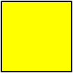**

**Name: \_\_\_\_\_\_\_\_\_\_\_\_\_\_\_\_\_\_**

This was a map of a garden Cody was going to plant. He was going to plant one plant in each of the squares. Someone spilled ink on his map. How many plants can Cody plant? Show or explain your thinking.

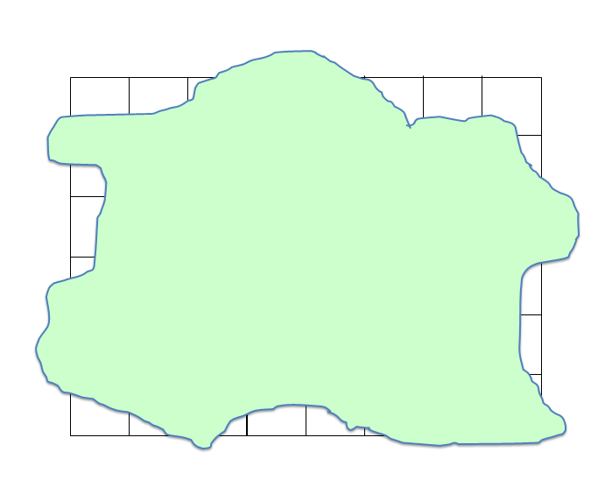

**Name: \_\_\_\_\_\_\_\_\_\_\_\_\_\_\_**

Kayla is decorating a bulletin board. The board is 5 feet by 4 feet. How many square feet of paper will she need to cover the bulletin board?

 Mia was planting a garden. She wanted it to be 40 square feet. If she made the length of the garden 8 feet, how many feet is the width?

* ?