Name __________________­­­­_________________

Name __________________­­­­_________________

[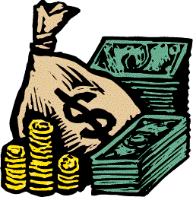](http://www.google.com/url?sa=i&rct=j&q=cartoon+image+of+coins&source=images&cd=&cad=rja&docid=mCmRG02M-_e-SM&tbnid=CFmuW4qBZC1JrM:&ved=0CAUQjRw&url=http%3A%2F%2Fdollarsawad.blogspot.com%2F2011_04_24_archive.html&ei=OfOLUejlFoGW8gTmuoHYCw&bvm=bv.46340616,d.dmQ&psig=AFQjCNG93-wpZhLIj9JBryGkLgr8bLREHQ&ust=1368212658015475)

Mario’s family is having a garage sale this weekend. To prepare for the sale his mom got a variety of dollar bills and coins to be able to give change to the customers. Mario

helped his mom carry the bag of coins out to the car.

* Using the spring scale, record the mass of the bag of coins (measure in grams).
* Mario found out the mass of one nickel is about 5 grams. In his bag there were 12 nickels. What was the mass of the 12 nickels? (measure in grams)