Name __________________­­­­_________________

[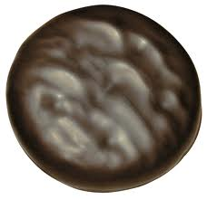](http://www.google.com/url?sa=i&source=images&cd=&cad=rja&docid=SFx6iNrGFfL84M&tbnid=S3O57h1Fdg6Y1M:&ved=0CAgQjRwwAA&url=http%3A%2F%2Fratzrow.wordpress.com%2F2012%2F03%2F28%2Fthrough-thick-and-thin-the-trusty-thin-mint%2F&ei=1P6LUcGAO8jh0wGR7YGAAg&psig=AFQjCNEyy45vMDqchOduvkHNV4_ZGJ2b_g&ust=1368215637026215)

Name __________________­­­­_________________

Girl Scouts sell lots of cookies to raise money for their program. One of their most popular cookies is the Thin Mint.

* Using the spring scale, estimate and record the mass of one chocolate mint cookie (measure in grams).
* Mary Ann found out that a chocolate cupcake measured 83 grams. What is the difference in mass for the chocolate cupcake and the cookie you measured? (record in grams)