**Standard addressed:**

|  |
| --- |
| **3.MD.1** Tell and write time to the nearest minute and measure time intervals in minutes**. Solve word problems involving addition and subtraction of time intervals in minutes, e.g., by representing the problem on a number line diagram.**   * Pose the following situation to your students: Jose gets off the bus at 3:05 pm every day after school. He has to be at soccer practice at 5:30. How long does he have to eat a snack and do his homework before he has to be at soccer practice? |
|  |

* Allow students time to work on the problem. Observe the strategies they are using and make notes about what student work you want to discuss at the end of the lesson.
* Choose student work to share with the class. This may be a good time to have students record new strategies in their math notebooks. Below are some strategies that you might see and want to bring out in your discussion.

**Possible Strategies to highlight:**

*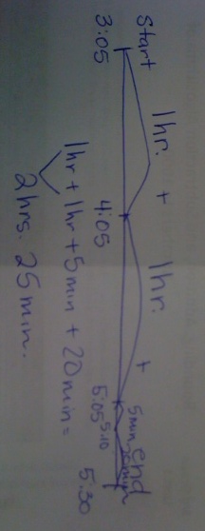Number Line Incrementing*

Students may use an open number line diagram to find the elapsed time. They will start with 3:05 and use a number line to mark the increments they used and keep track of the time at the top. This really addresses the “using diagrams such as number line diagrams that feature a measurement scale”.

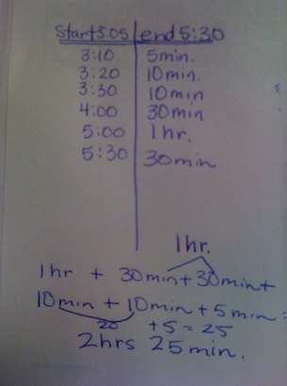

*T-Chart Organizer*

Students may flip the number line and use a t-chart to solve this problem. They may collect the units in different increments, but the idea is the same. This is a very organized way for students to organize and keep track of the elapsed time.

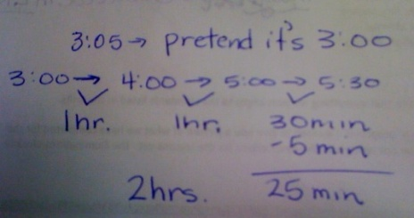

*Compensating*

Some students may compensate in some way, but rounding off the time to the nearest hour, finding the elapsed time and then deal with the difference at the end. This is also a very friendly strategy for finding the elapsed time.