1. (2.MD.2) Jim measured the carpet in the classroom with his planner and then with a crayon. He got these two measurements: 25 and 12.

Which measurement was the planner and which was the crayon?

(Write crayon or planner in the blank)

25 ____________

12 ____________

Why were the measurements different?

1. (2.MD.2) Casey wants to find the length of her desk with one book, but her book is not as long as her desk.

Length

Casey’s desk

Book

Can Casey use only one book to measure her desk? Explain.

1. (2.MD.6) This ruler is 3 units long. Show where the inches are and label the ruler.

(2.MD.4) Use the Inch ruler and picture to answer problems 4-6

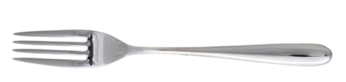

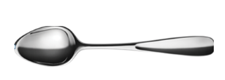

[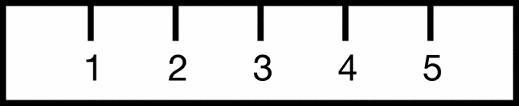](http://www.google.com/url?sa=i&rct=j&q=&esrc=s&frm=1&source=images&cd=&cad=rja&docid=4m3wZOFETgC8TM&tbnid=DTaLMizIHES3iM:&ved=0CAUQjRw&url=http%3A%2F%2Fetc.usf.edu%2Fclipart%2F41600%2F41630%2Fruler6_41630.htm&ei=1oNqUo3SKYyDkQeT_IGYAg&bvm=bv.55123115,d.b2I&psig=AFQjCNHHncFOqSFA7sE1ZlF24UIcVaWH3Q&ust=1382798666111886)

1. The spoon is ____ inches long.
2. The fork is ___ inches long.
3. How much longer is the fork than the spoon?
4. (2.MD.5) Ms. Shreve was putting a border around her bulletin board. How many inches of border does she need?

35 inches

[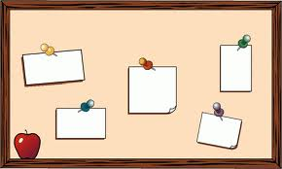](https://www.google.com/imgres?imgurl&imgrefurl=http%3A%2F%2Fwww.clipartpal.com%2Fclipart_pd%2Feducation%2Fbulletinboard1.html&h=0&w=0&sz=1&tbnid=2anmE_6LCG3IXM&tbnh=174&tbnw=290&zoom=1&docid=PTvLMoSDPZBOGM&ei=YY5qUoKeKtT5kQebroCoAQ&ved=0CAEQsCU)

20 inches

20 inches

35 inches