[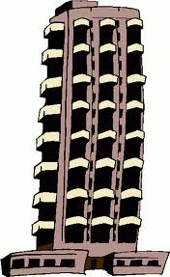](http://www.google.com/url?sa=i&rct=j&q=&esrc=s&frm=1&source=images&cd=&cad=rja&docid=JSpcdvVcqAslCM&tbnid=HxQtToQYVs7hjM:&ved=0CAUQjRw&url=http://www.clipartheaven.com/show/clipart/business_&_office/buildings/office_building_12-gif.html&ei=L1ieUoLfKMWT2gWL-4HYAQ&bvm=bv.57155469,d.b2I&psig=AFQjCNGcAxQKDwKfvn1guXblB1iHnYL7rw&ust=1386195352418900)

1. The building is ____ units tall. Label the tool to prove your answer.
2. This measuring tool is 3 units long. Please label the tool with whole units and half units.