Unit 1 | Unit Title: A Colorful Time with Rhythm and Rhyme  Unit Essential Question: How do questions help us learn?
MATERIALS | 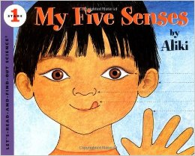  My Five Senses by Aliki
STANDARDS | W.K.1
Lesson Structure | High Yield Strategies | Lesson Plan
GOAL  (2 minutes) | (8) Setting Objective and Providing Feedback | I can write to tell my opinion.
ACCESS PRIOR  KNOWLEDGE  (3minutes) | (6) Nonlinguistic Representations  (7) Cooperative Learning  (10) Cues, Questions and Advance Organizers | Find a variety of objects students can feel or listen to different sounds.  How do they make you feel?
NEW  INFORMATION | (3) Summarizing and Note Taking  (11) Teaching Specific Types of Knowledge | Reread the book My Five Senses.  Interactive Writing  Example: I like to smell __________.
APPLICATION | Declarative  (3)Generating and Testing Hypotheses  (10) Cues, Questions and Advance Organizers | Procedural  (5) Homework and Practice | Students will write about a different sense each day in their “5 Senses Book”.
GOAL  (2 minutes) | (8) Setting Objective and Providing Feedback  (4) Reinforcing effort and Providing Recognition |  | I can write to tell my opinion.
Grade___Kindergarten______ Date_______________

