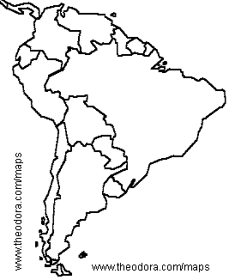

People

Landforms

Weather

Places

Animals