Europe
RI.K.2
W.K.2
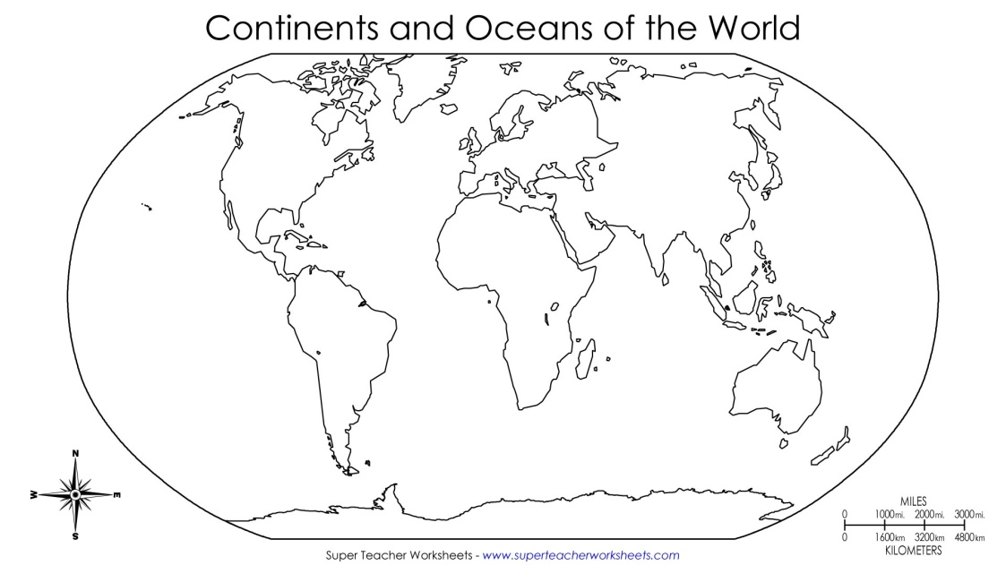  Find and color Europe | Places to See  Draw 1 place to see in Europe
Types of Land and Water  Draw 1 type of land or water found in Europe | People and Countries  Draw the people of 1 country in Europe

__________________
__________________
__________________
__________________

