RI.K.2

W.K.2

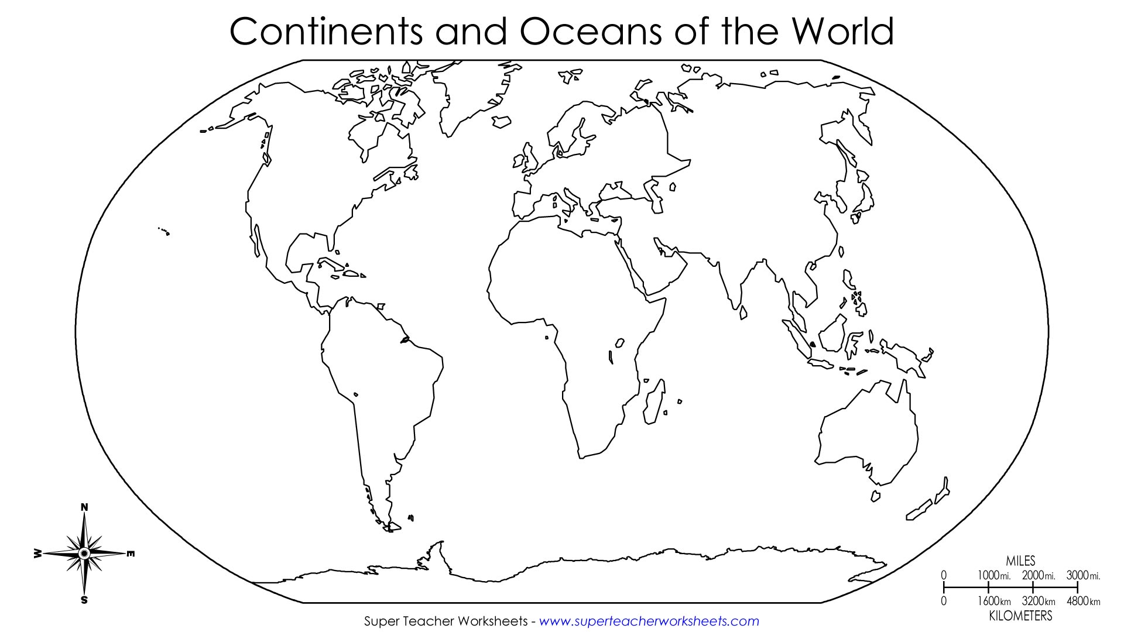

**Name ______________________________________________________________________**

The Continents



**7**

**1**

**6**

**4**

**2**

**5**

**3**

|  |  |  |  |
| --- | --- | --- | --- |
| North America  http://www.theplanningboardroom.net/wp-content/uploads/2011/01/sydney-city-buildings.jpg | [Tropical Rainforest (5)](http://tourists360.com/wp-content/uploads/2014/02/Tropical-Rainforest-5.jpg)South America | http://l.rgbimg.com/cache1ouVFQ/users/t/ta/tacluda/600/mv8SdhS.jpgAsia | http://www.onthegotours.com/repository/ImperialCitiesAndDesertsItineraryMainTailormadeHolidaysMorocco-48521241806298_crop_538_259_f2f2f2_center-center.jpgAfrica |
| http://www.planetware.com/photos-large/F/eiffel-tower.jpgEurope | http://intelligenttravel.nationalgeographic.com/files/2013/09/penguins-antarctica.jpgAntarctica | http://upload.wikimedia.org/wikipedia/commons/1/15/Sheep_and_cow_in_South_Africa.jpgAustralia |  |
| North America  http://www.theplanningboardroom.net/wp-content/uploads/2011/01/sydney-city-buildings.jpg | [Tropical Rainforest (5)](http://tourists360.com/wp-content/uploads/2014/02/Tropical-Rainforest-5.jpg)South America | http://l.rgbimg.com/cache1ouVFQ/users/t/ta/tacluda/600/mv8SdhS.jpgAsia | http://www.onthegotours.com/repository/ImperialCitiesAndDesertsItineraryMainTailormadeHolidaysMorocco-48521241806298_crop_538_259_f2f2f2_center-center.jpgAfrica |
| http://www.planetware.com/photos-large/F/eiffel-tower.jpgEurope | http://intelligenttravel.nationalgeographic.com/files/2013/09/penguins-antarctica.jpgAntarctica | http://upload.wikimedia.org/wikipedia/commons/1/15/Sheep_and_cow_in_South_Africa.jpgAustralia |  |

__________________

__________________

__________________

__________________