Australia
RI.K.2
W.K.2
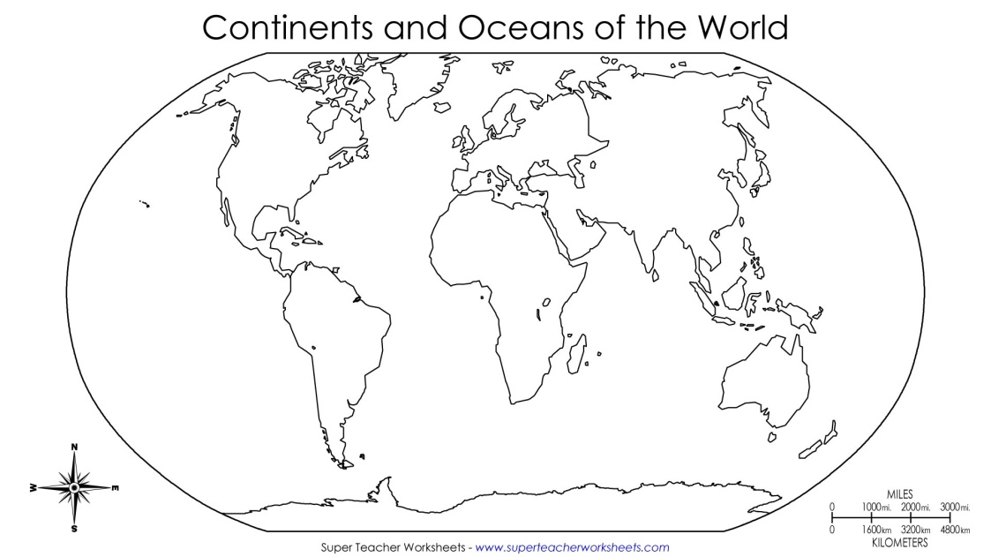  Find and color Australia | Types of Land  Draw 1 type of land found in Australia
Landmarks  Draw 1 landmark found in Australia | Animals  Draw 1 type of animal found in Australia

__________________
__________________
__________________
__________________

