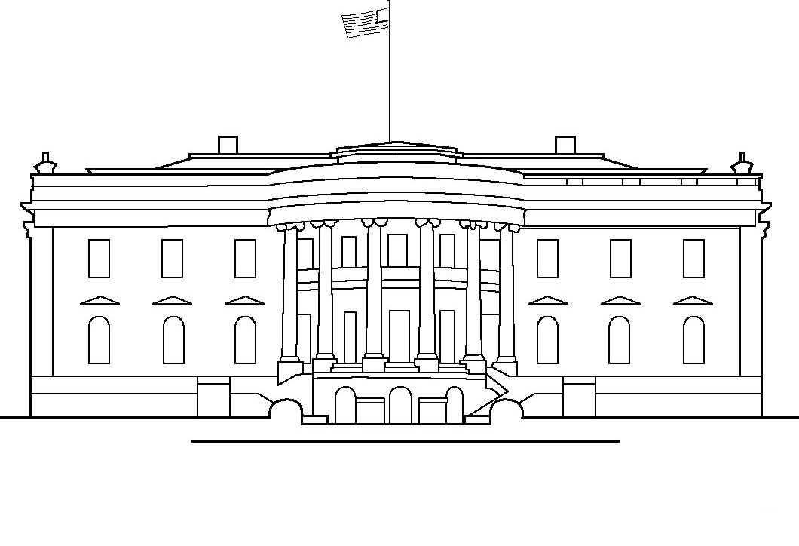

The White House is _____ ___ ____

____________________________

It has _______________________

____________________________