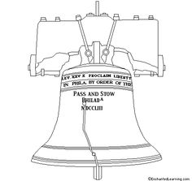

The liberty bell stands for ___ ____

____________________________

It has a ______________________

____________________________